Stablebaseline3 @ RAJKARAN YASODHADEVI PONNUVELUSAMY

What is Stable-Baselines3?

Stable-Baselines3 is a popular Python library that provides implementations of reinforcement learning (RL) algorithms. These algorithms are designed to help machines learn how to make decisions by interacting with an environment and receiving feedback (rewards or penalties). It is like a toolbox with pre-built tools (algorithms) that can be used to train AI models to solve complex tasks, like playing games, controlling robots, or managing financial portfolios.

SB3 provides us with various algorithms like PPO, DDPG, TD3, A2C, SAC and more. These algorithms help the agent learn the best actions to take in different situations.

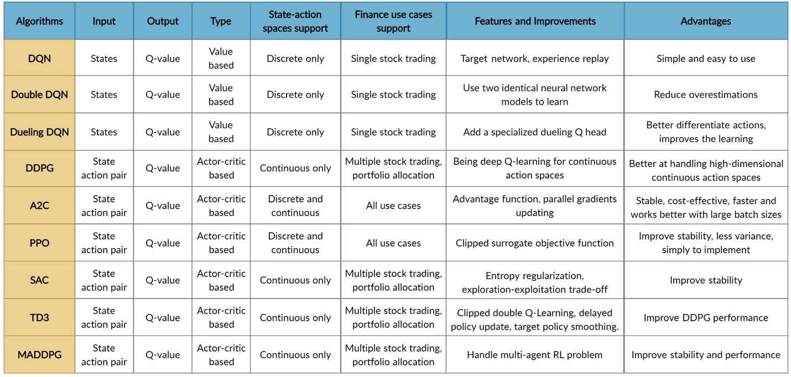

How Does Stable-Baselines3 Work?

In-order to understand this we need to know how Reinforcement learning works.

Reinforcement Learning Basics:

  - An agent (the AI model) interacts with an environment (e.g., a stock market simulation).

  - The agent takes actions (e.g., buying or selling stocks) based on the current state of the environment (e.g., stock prices, portfolio value).

  - After each action, the agent receives a reward (e.g., profit or loss) and moves to a new state.

  - The goal of the agent is to learn a policy (a strategy) that maximizes the total reward over time.

How SB3 works:

- Environment: We need to define or use an existing environment (e.g. from OpenAI Gym, Atari, robotics simulators, or custom environments) where our AI agent will interact. By interacting with the environment, the smart agent will derive a trading strategy to maximize the long-term accumulated rewards (aka; Q-value).

- Agent: Then we need to choose an algorithm from Stable-Baselines3 (e.g., PPO) to create an agent. FinRL's agents are built by fine-tuned standard DRL algorithms depending on three famous DRL library: ElegantRL, Stable Baseline 3, and RLlib.

- Training: This agent will then interact with the environment, collects experiences, and learns to maximize cumulative rewards by updating its policy.

- Evaluation: After training, we can evaluate the agent's performance in the environment.

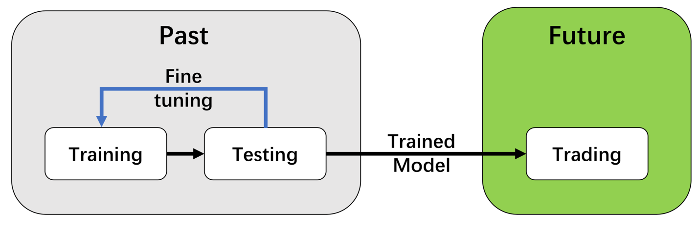

Why Use Stable-Baselines3 in FinRL?

- Ease of Use: Stable-Baselines3 provides pre-built algorithms, so you don’t need to code them from scratch.

- Flexibility: You can customize the environment, state, actions, and rewards to suit your specific needs.

- Performance: The algorithms are optimized for efficiency and can handle complex tasks like portfolio management.

Best RL Algorithms for our Portfolio Allocation Strategy (Less Compute-Intensive & Best for Portfolio Allocation)

Algorithm | Why Choose It? | Compute Intensity
Proximal Policy Optimization (PPO) | 🔹 Works well on large datasets.  🔹 Less compute-heavy than TRPO.  🔹 Stable learning, good for long-term strategies. | ⚡ Low-Medium
Twin Delayed DDPG (TD3) | 🔹 Handles continuous allocations.  🔹 More efficient than DDPG (avoids overestimation bias).  🔹 Optimizes risk-adjusted returns. | ⚡ Low-Medium
Soft Actor-Critic (SAC) | 🔹 Best for risk-sensitive portfolios.  🔹 Trades slightly higher compute cost for better stability. | ⚡ Medium
Advantage Actor-Critic (A2C) | 🔹 Efficient policy optimization.  🔹 Handles risk & reward trade-off well.  🔹 More lightweight than A3C. | ⚡ Low
Multi-Agent DDPG (MADDPG) | 🔹 Each stock/sector gets an individual AI agent to learn optimal strategies.  🔹 Good for sector diversification [e.g. Oil vs. Airlines]. | ⚡⚡⚡Very High

Value based algorithms like DQN and Double DQN are Not ideal for portfolio allocation. Use Policy-Based Methods instead.

Not Suitable algorithms for our Portfolio Allocation.

Algorithm | Reason for not choosing
Trust Region Policy Optimization (TRPO) | 🔹 Similar to PPO but slower.  🔹 More conservative updates → reduces volatility but is less scalable.
Deep Q-Network (DQN) | 🔹 Works for discrete actions (Buy/Sell).  🔹 Not ideal for portfolio allocation (doesn't support continuous weight adjustment).

Final Recommendation (Best Balance of Performance & Compute Efficiency)

Algorithm | Compute Cost | Portfolio Allocation | Sector Diversification | Handles Risk Appetite (Low/Medium/High)? | Final Verdict
PPO ✅ | ⭐⭐ (Moderate) | ✅ Excellent | ✅ Can add sector constraints | ✅ Handles risk via reward shaping | Best Overall Choice
TD3 ✅ | ⭐⭐ (Moderate) | ✅ Precise portfolio allocation | ✅ Can balance sectors | ✅ Handles risk by controlling action noise | Best for fine-tuning allocations
SAC ✅ | ⭐⭐⭐ (Moderate-High) | ✅ Risk-aware allocations | ✅ Ensures stable diversification | ✅ Uses entropy tuning for risk control | Best for adaptive risk management
A2C ❌ | ⭐ (Low) | ✅ Decent | ❌ Not explicitly industry-focused | ❌ Limited risk control | Too simple ❌
MADDPG ✅ | ⭐⭐⭐⭐ (Very High) | ✅ Excellent for multi-stock trading | ✅ Best for sector-based agents | ❌ Not designed for risk levels | Too compute-intensive ❌

Final Recommendation (Best Trade-Off)

PPO ✅ → Best overall for portfolio allocation, diversification, and risk control.
TD3 ✅ → Best for fine-tuning allocations across different risk levels.
SAC ✅ → Best for adaptive risk management (dynamically adjusts based on volatility).

